Delivery Services:

**FRIAS‘s Shipping Process is stated below ☺**

**We provide 3 different kinds of delivery/collection methods:**

**1) Budget Delivery**

**S$3.90** for parcel weighing less than or equal to **3kg**.

**S$4.90** for parcel weighing between **3kg** to and including **5kg**.

**S$6.90** for parcel weighing between **5kg** to and including **8kg**.

**S$0.50** for every following **1kg**, up to a maximum of **S$25.00**.

**Note:**

(For all deliveries, weight under 1kg will be charged as 1kg)

**2) MRT Station Delivery**

**Only available for items weighing 8kg or less.**

Free–of–charge service, item is delivered to designated MRT station and designated timeslot. SMS notification will be sent on day of collection.

Strictly no waiting for late–comers; re-arrangements will be required for those who miss their collections.

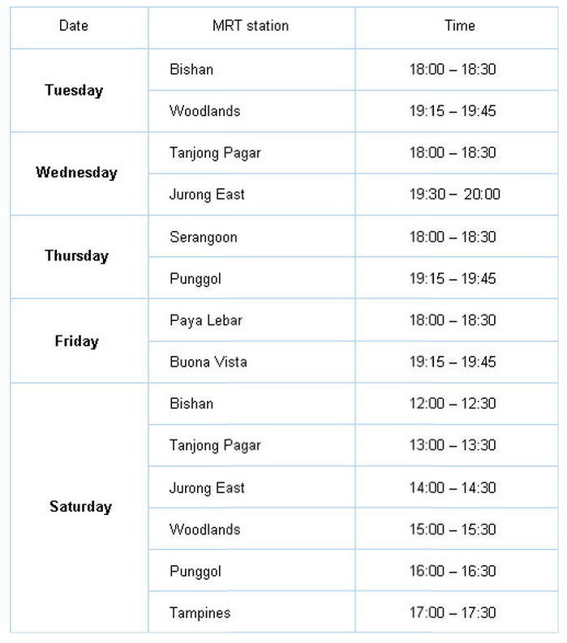

**3) Self Collection at Warehouse**

You can choose to self-collect your item at your warehouse, through selected timeslots. Upon collection, kindly verify with FRIAS your username, collection ID, and contact number.

|  |
| --- |
| ADDRESS 100, Orchard Crescent, Singapore, 100000. |
| OPERATING HOURS  Monday – Fridays 9:30 am to 11:00 pm  Saturdays 9:30 am to 9:00 pm  Sundays 9:30 am to 10:00 pm |
| BY BUS  Bus no.: 1N, 2N, 3N, 4N, 5N, 6N, 7, 14, 16, 36, 65, 77, 106, 111, 124, 162, 162M, 167, 171, 174, 175, 190, 502, 518, 700, 700A, NR7  Alight at: Concorde Hotel Singapore (Stop ID: 08138) |
| BY TRAIN  Either Dhoby Ghaut MRT Station or Somerset MRT Station |
| CUSTOMER SERVICE HOTLINE  +65 4444 6677 |

**Notes:**

* Please come within your selected timeslot to avoid delays.

* Payment has to be done before collection, otherwise your selected timeslot will be cancelled. Re-submission will then be required.

**FAQ**

1. **How long will it take for shipping?**

By non-registered mail, it usually will take 1-2 weeks from the shipping date for local delivery (Singapore) and will take 4 weeks for international delivery (customer from overseas). It may take over 4 weeks for local / international delivery depending on situation.

By registered mail (Standard), it usually will take 1 week from the shipping date for local delivery and will take 1-2 weeks for international delivery. International delivery to overseas may take over 3 weeks.

|  |  |  |
| --- | --- | --- |
| Shipping Method | | Shipping Period |
| Non-Registered mail | Local customer ( Singapore) | 1-2 weeks |
| International (Overseas) | 2-4 weeks |
| Registered mail | Local customer (Singapore) | 1 week |
| International (Overseas) | 1-3 weeks |

1. **Can I return items?**

It’s okay to change your mind! Bring back or mail back to FRIAS that your unassembled items with the original packaging and your receipt within 100 days for an exchange or refund. We will afford your fees of mailing back.  
  
We regret that we are unable to accept returns of assembled goods, cut fabrics & blinds, goods damaged after leaving the FRIAS store except due to items on sale and products of jeans. Please refer to the return policy stated below.

Return Policy:

No nonsense return policy ☺ Love it or exchange it

Return the unassembled item in their original packaging within 100 days, together with your receipt for either an exchange or a full refund. Refunds will be issued in the same method of payment as the original payment. Purchases made with cash: a cash refund will be issued. Purchases made with a credit card: credit will issued to the original card. Original card must be presented at time of return.   
  
Our 100-day return policy does not apply to cut fabric, products from beach, goods ordered to your specifications e.g. custom-made worktops, damaged items resulting from misuse, abuse, normal wear & tear and incorrect self-assembly and products damaged after leaving the store.

1. **Why are items sometimes out of stock?**

Every effort is made to maintain the availability of items shown in the catalogue, brochures, leaflets, newsletters, website and the showroom, but due to popularity and supply issues, some products may not always be available. Generally, we can estimate when a product should be back in stock. Because FRIAS products are manufactured throughout the world, there are sometimes circumstances which can cause delivery delays.

1. **How is the purchasing processes?**

**1st step: Payment processing**: The order was processed, however the payment has yet to be confirmed.  
  
**2nd step: Shipping requesting**: Payment is completed and order info will transfer to FRIAS.   
  
**3rd step: Shipping requested:** FRIAS verifies the payment and order but the item(s) has yet to be shipped.  (The ordered items can still be changed or cancelled at this stage.)  
  
**4th step: Shipping** **scheduled**: FRIAS is preparing to ship out the item but the item(s) has yet to be shipped. (The ordered items can be changed or cancelled with FRIAS's confirmation at this stage.)  
  
**5th step: Shipping on delivery**: The item has been shipped out and the item is on its way to the destination. Any changes to the order are not possible at this point and a return request must be submitted at this point  
  
**Last step: Shipping delivered**: When the items are delivered to the customer, the customer needs to click on confirm delivery button in Shopping list and then the status will be changed to “delivered”.   
If you don't receive the item but the status is changed to “delivered” through the system, kindly click on non-receipt claim in shopping list. (Non-receipt claim button is available 7days only from the date of delivered.)